2019 Dates to Remember
- Friday 1st November
Fab Friday
- Monday 4th November
Pupil free day
- Tuesday 5th November
Cup day Public Holiday
- Wednesday 6th Nov - Friday 8th Nov
Grade 3/4 camp to Lake Nillahcootie
- Tuesday 12th November
Skillzone 3/4 after school
- Tuesday 19th November
Skillzone 4/5 after school
- Saturday 23rd November
School Fete and Market day
- Tuesday 26th November
Skillzone 5/6 after school
- Tuesday 3rd December
Skillzone Prep after school
- Thursday 5th December
Grade 6 graduation 6pm start
- Tuesday 10th December
Skillzone 1/2 after school
- Tuesday 17th December
Presentation evening/ Christmas fun night & BBQ

SRC will be selling
Zooper Doopers
Every Wednesday & Friday
$1.00

SCHOOL FETE
ADVERTISING IS A GREAT WAY TO GET PEOPLE TO THE FETE. IF YOU ARE ABLE TO DISPLAY THE FLYER AT YOUR WORKPLACE OR ANYWHERE ELSE FEEL FREE TO POP INTO OFFICE AND GRAB SOME MORE FLYERS.
PARENTS AND FRIENDS NEWS

Term 4

- Chicken drive TBA
- 23rd November School fete
- 6th December family movie night

Accepting Differences.
To get along with other people, it’s necessary to be tolerant of the ways they are different from you. Our world is made up of people from many different cultures, races, and backgrounds. We all want to be liked and treated well, and stereotypes and prejudice only foster bad feelings. If we respect each other’s differences, we can all learn from each other. No matter how different people look or act, we should always give everyone a “fair go.” It takes time to really get to know people—beyond the way they look, talk, or act. And think about it: wouldn’t the world be a boring place if everyone were the same?

RESPECT
Breakfast Club is Back !!!
Every Friday Parents & Friends will be running breakfast from 8:30am in the hall.
They offer cereal, toast, juice and hot chocolate.

Ph: 58745295 Fax: 58745537
Email:Strathmerton.ps@edumail.vic.gov.au
TRY YOUR
BEST

SUPPORT EACH
OTHER
ACT
SAFELY

Newsletter No.35
October 31st 2019
From the Principal’s desk
Dear Parents,
Remember we have a ‘pupil-free day’ on Monday next (4/11), so that staff can plan programs and activities for 2020. At School Council last night, the class structure and teaching staff for 2020 were discussed. Below I have listed those classes and our teaching team for 2020. Actual decisions as to which teacher will be teaching which class, haven’t been decided as yet. However, that information will be passed on to you nearer the end of the year.
CLASSES AND STAFF FOR 2020
As we have a smaller intake of Preps for next year and a larger exiting group of Year 6’s this year, our overall enrolment will drop to between 95-100 students. Therefore we will run five classrooms (the Year 5/6’s will return to a classroom in the main building). Those classes will be a Prep/1, 1/2, 2/3, 4/5 and 5/6. We will be farewelling two teaching staff at the end of the year and welcoming one new teacher for 2020. Stefanie Knight and Alysha Wilson will be moving on and Christine Doyle (currently teaching at Cobram Primary) will be joining us.
So our classroom teaching staff will be Rachel Olson (Learning Specialist), Glenice Sefton, Jacob Gillie, Mona Alam and Christine Doyle. Supporting the classrooms will be Trevor Mills (Leading Teacher) - PE teacher, SWPBS coordinator and student welfare; Kristi Cleary - Library and Auslan; Yvonne Cleary -Art and Tania Broadwood - Literacy Intervention. We will also have Dawn Powles (classroom support and garden) and Lynda Dickson (classroom support) assisting individual students. In addition, we will continue to employ the services of Elizabeth Ruscoe (Flow Speech Pathology) to provide speech therapy to identified students as well as access further speech therapy and social worker support from the SSSO service in the Regional Office.
WALK TO SCHOOL DAY
This morning our whole school walked ‘around the block’ as our way of supporting the Walk To School initiative promoted by the State Government and supported by the Moira Shire. The small grant provided by the Shire was used to buy fresh fruit which the children all enjoyed after our walk, as well as providing the opportunity to purchase new vegetable seedlings for our school garden. Thanks to Glenice Sefton who coordinated this whole event.
MR GILLIE’S WEDDING
Big congratulations to Jacob Gillie and his partner Amy on their upcoming wedding this Saturday. Jacob is a fine young man and Amy a wonderful young lady and we wish them all the best for their wedding and a long and successful future together.
GRADE 3-4 CAMP
The Year 3-4’s are eagerly looking forward to their upcoming camp at Lake Nillahcootie. It will make a great week for them with the Pupil-Free Day on Monday, 4th November, Melbourne Cup on the Tuesday and then their camp from the Wednesday to the Friday, there is still a number of outstanding payments for this camp that will need to be paid at the office before 6th November.
Have a great weekend,
Geoff Weppner.

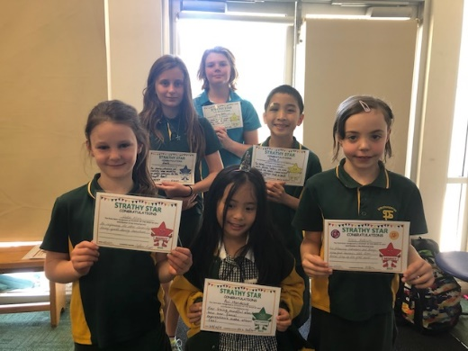
STRATHY STARS

Harry Barnes, Giselle Wren, Nicky P, ,Sadie Wren, Avi Mendoza, Felicia Anderson

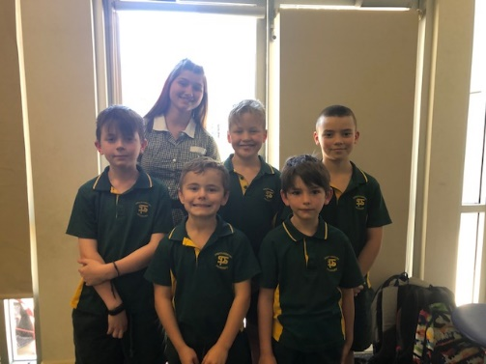
Dakota Kelly, Harry Wood, R J Patmore,m Mykel Argus, Bailey Sanderson, & Kayden Safe

Literacy Award
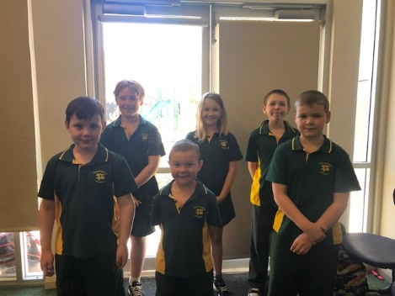
Codey Edgar, Lila Whitaker, Kyri Novoselac, Oliver Bramich, Axel Hendeson & Owen Perry

Maths Award

Oliver Bramich and Max Bayne are the lucky barrel winners this week.

FETE DONATIONS

STALL | NEWSLETTER DONATIONS
1 BAKE STALL | Flour, sugar, butter, icing sugar, cocoa, Packet mixes
2 LUCKY JARS | Any item to put into a jar, lollies, toys, teabags, gifts
3 SHOW BAGS | Any item you would find in a show bag, toys, lollies, ice blocks, rulers, note books, pencils
4 TOSS A CHOC | Chocolates of all sorts, bars, blocks, Freddos
5 PLANT STALL | Plants potted ready for sale and anything to do with gardening to sell
6 BAKE STALL / HIGH TEA BUDGET STYLE | Cakes, slices any home made goods for Stall- nothing with Cream.  Cakes, Slices and Sandwiches for High Tea

FETE
The Prep grade are running the tattoo and finger nail painting stall at the fete. We need a variety of nail polish colours. We would appreciate any donations. (Half used bottles of nail polish would be accepted)
Thanks you Mrs Sefton

