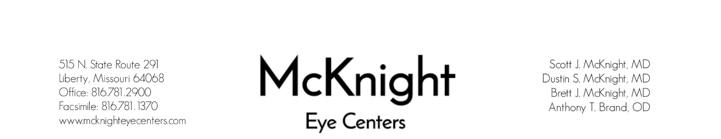

DATE OF YOUR APPOINTMENT | TIME OF YOUR APPOINTMENT

Office Hours:
Monday – Thursday: 7:00AM – 5:00PM
Friday: 7:00AM – NOON

YOUR APPOINTMENT WILL BE WITH:
Scott J. McKnight, MD
Dustin S. McKnight, MD
Brett J. McKnight, MD
Anthony T. Brand, OD
PLEASE BRING WITH YOU:
All current Insurance Cards
A referral if required by your insurance
A current list of ALL MEDICATIONS
A current POA/DPOA if needed

Dear Patient,
Thank you for selecting McKnight Eye Centers for your eye care. We are committed to providing quality eye care. We have enclosed forms requesting the basic information for your medical record. Please complete the forms and bring them to your first visit to expedite checking-in.
Your first visit at McKnight Eye Centers will consist of a complete eye exam. The initial visit usually lasts for approximately 2 hours, however, may vary in length depending on the diagnosis made by your doctor. Your eyes may be dilated during this visit and we recommend you bring a pair of sunglasses to protect your eyes from the sun. You may even wish to have someone drive.
Sincerely,

McKnight Eye Centers & Staff
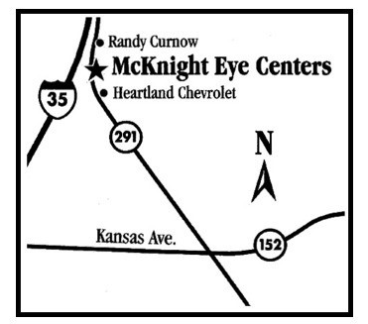
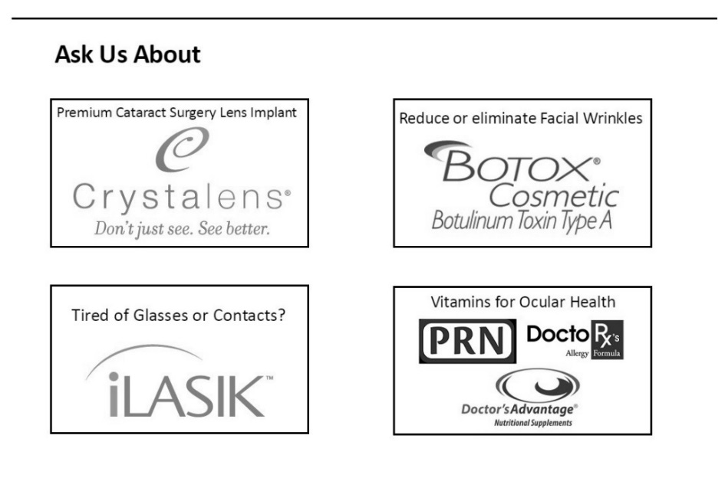

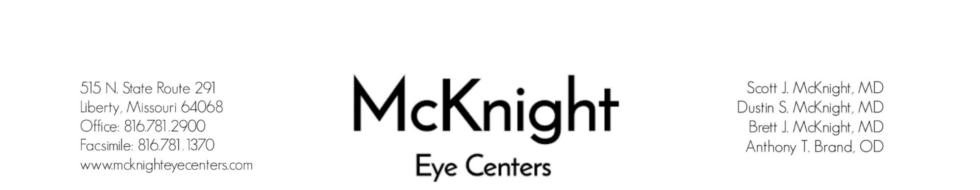

Today’s Date: |  |  |  |  |  |  |  | Date of Birth:
Last Name: |  |  |  |  | First: |  |  |  |  |  | Middle Initial:
MARITAL STATUS | GENDER |  | RACE |  |  |  | ETHNICITY |  |  |  |  | PREFERRED LANGUAGE
- Married  - Single | - Male  - Female |  | - Caucasian  - African American  - Alaskan Native  - Asian/Pacific Islander  - Native American |  |  |  | - Hispanic/Latino  - Not Hispanic/Latino  - Other |  |  |  |  | - English  - Spanish  - Other:  ____________________
Street Address:
City: |  |  |  |  |  |  |  |  |  | State: |  | Zip Code:
Home Phone: |  |  |  |  |  |  | Cell Phone:
SSN: |  |  |  |  |  |  | Email:
EMPLOYMENT
Employer:
Work Phone: |  |  |  | Position/Department:
NURSING HOME
- Not Applicable  - Nursing Home Patient  - Hospice Patient  - Skilled Nursing |  | Facility:
 |  | Address:
 |  | Phone Number:
PRIMARY CARE
Primary Care Doctor: |  |  |  |  |  |  |  |  | Phone Number:
Optometrist: |  |  |  |  |  |  |  |  | Phone Number:
PRIMARY INSURANCE
Primary Insurance: |  |  |  |  |  |  |  |  | Policy Number:
Policy Holder: |  |  |  |  |  |  |  |  | Date of Birth:
SECONDARY INSURANCE
Secondary Insurance: |  |  |  |  |  |  |  |  | Policy Number:
Policy Holder: |  |  |  |  |  |  |  |  | Date of Birth:
EMERGENCY CONTACT OUTSIDE OF THE HOME
Name: |  |  |  |  |  |  |  |  | Phone:
Relationship to Patient:
REFERRAL |  |  |  |  |  | PATIENT SPECIAL NEEDS
- Friend/Family  - Internet  - Yellow Pages  - Other  - Physician |  |  |  |  |  | - Wheelchair Is patient able to transfer? Y N  - Translator  - Hearing Impaired  - Oxygen Dependent  - Other:

PATIENT NAME: | DATE OF BIRTH:

Y | N | PATIENT HISTORY | Y | N | FAMILY HISTORY
 |  | Asthma |  |  | Glaucoma
 |  | Kidney Disease |  |  | Cataracts
 |  | Diabetes IDDM/Type II/No. of Yrs: |  |  | Macular Degeneration
 |  | Insulin Dependent |  |  | Diabetes IDDM/Type 2
 |  | Migraines |  |  | Heart Disease
 |  | Psychiatric Disorder |  |  | Retinal Detachment
 |  | Nervous Disorder |  |  | Stroke
 |  | Heart Disease |  |  | Cancer
 |  | Sickle Cell Anemia |  |  | Blindness
 |  | Tobacco Use |  |  | Amblyopia
 |  | Alcohol Use |  |  | Arthritis
 |  | Illegal Substance Use |  |  | Auto Immune Disease:
 |  | Extensive Confinement by Illness or Injury |  |  | Migraines
 |  | Arthritis |  |  | Hypertension
 |  | Permanent Defect of Eye from Injury/Illness |  |  | Kidney Disease
 |  | Currently Pregnant |  |  | Thyroid Disease
 |  | High Blood Pressure |  |  | Other:
 |  | Stroke
 |  | HIV
 |  | Auto Immune Disease:
 |  | Cancer
 |  | High Cholesterol | SURGICAL HISTORY |  |  | DATES
 |  | Head or Spinal Injuries
 |  | Seizures, Convulsions, or Fainting
 |  | Corneal Disease
 |  | Glaucoma
 |  | Cataracts
 |  | Retina Disease
 |  | Iris Disease/Injury
 |  | Other:

MEDICATIONS/VITAMINS (STRENGTH AND DOSAGE) | ALLERGIES/REACTIONS
TECHNICIAN: | DATE:

AUTHORIZATION FORM FOR OTHER USES OF PROTECTED HEALTH INFORMATION
Our Notice of Privacy Practices provides information about how we may use and disclose protected health information (PHI) about you and pursuant to our general Practice, may want to use PHI for reasons other than treatment, payment, and health care operations. This form summarizes the anticipated use of information about you for which this authorization is required. The practice provides this form to comply with Health Insurance Portability and Accountability Act of 1996 (HIPAA).
PREFERRED METHOD OF COMMUNICATION |  | MAY WE LEAVE A MESSAGE AT THIS NUMBER (YES/NO)
1. |  | YES | NO
2. |  | YES | NO
PLEASE LIST ANY OTHER PARTIES WHO YOU WOULD ALLOW US TO SHARE YOUR HEALTH INFORMATION
NAME | RELATIONSHIP TO PATIENT | PHONE NUMBER
1.
2.
3.
4.
Additional Notes: ________________________________________________________________________________________________________________________________________________________________________________________________________________________________________________________________________________________________
*The above-mentioned protected health information may be subject to re-disclosure by the party receiving the information and may no longer be protected by the privacy rules.
*By signing this form, you authorize the Practice to use and disclose protected health information about you for the reasons mentioned above. You have the right to revoke this authorization at any time, in writing, signed by you. However, such a revocation shall not affect any disclosures we have already made in reliance on your prior authorization. Submit your revocation to the Privacy Officer or the Practice.
The authorization was signed by: ___________________________________________ DOB: _____________________
(Printed Name of Patient or Representative) (Patient’s Date of Birth)

___________________________________________ DATE: ____________________
(Signature)

Witness: _______________________________________________________________ DATE: ____________________
(Signature)

Expiration date of authorization: ____________________________________

McKnight Eye Centers, PC
Receipt of Notice of Privacy Practices
Written Acknowledgement Form
And
Patient Consent for Use and Disclosure of
Protected Health Information

Patient (Print) Name: | Date of Birth:
PLEASE READ AND INITIAL BELOW
I have received, or have been offered, a copy of McKnight Eye Centers, PC Notice of Privacy Practices.
I hereby give my Consent for McKnight Eye Centers, PC to use and disclose protected health information (PHI) about me to carry out treatment, payment, or health care operations as described in the Notice of Privacy Practices that I have been provided.
I understand that I have the right to review the Notice of Privacy Practices prior to signing this Consent.
I understand that I have the right to request that McKnight Eye Centers, PC restrict how it uses or discloses my PHI to carry out treatment, payment or health care operations. However, the practice is not required to agree to my requested restrictions, but it is bound by this agreement.
I understand that I may revoke my Consent in writing, except to the extent the practice has already made the disclosures in reliance upon my prior Consent. If I do not sign this Consent, or later revoke it, McKnight Eye Centers, PC may decline to provide treatment to me.

Signature of Patient: | Today’s Date:
McKnight Eye Centers, PC reserves the right to revise its Notice of Privacy Practices at any time.
A revised Notice of Privacy Practices may be obtained by forwarding a written request to:

McKnight Eye Centers, PC
Attn: Compliance Director
515 North State Route 291
Liberty, Missouri 64068

MAIL ORDER
PHARMACY AUTHORIZATION

Patient (Print) Name: | Date of Birth:
I hereby give McKnight Eye Centers permission to submit medication prescription requests to my mail order pharmacy, on my behalf. |  | YES | NO
Mail Order Pharmacy Information:

Signature of Patient: | Today’s Date:

POWER OF ATTORNEY

Patient (Print) Name: |  | Date of Birth:
PLEASE CHECK WHICH APPLIES TO PATIENT

 | I DO have a Power of Attorney, and I am aware that if I am scheduled for any surgery or procedure with McKnight Eye Centers or it’s designated surgical facility, that my Power of Attorney must be present and in agreeance.
 | I do NOT have a Power of Attorney, and I am aware that should I obtain one, that it is solely my responsibility to present that information upon arrival at McKnight Eye Centers.
Signature of Patient: |  | Today’s Date:

POWER OF ATTORNEY INFORMATION

Name: | Phone Number:
Address:

PLEASE PROVIDE MCKNIGHT EYE CENTERS WITH A CURRENT COPY OF THE
POWER OF ATTORNEY FOR OUR RECORDS.

AGREEMENT OF RESPONSIBILITY
I understand that professional services are rendered to the patient and the patient is responsible for charges incurred for these services. Payment for annual deductible and co-insurance may be collected at the time of service. I understand that I am financially responsible for charges as a self-pay patient or charges not covered by my insurance.
CONSENT TO TREAT
I voluntarily consent to such care and treatment as prescribed by the physician as is necessary in his/her judgment.
RELEASE OF INFORMATION/ASSIGNMENT OF BENEFITS
I authorize use of this form on all my insurances submissions and authorize release of information needed to process a claim to all my insurance companies. I permit a copy of this authorization to be used in place of the original. I authorize the provider to act as my agent in helping me obtain payment from my insurance companies. I understand the provider does not accept responsibility for collecting my insurance claims or for negotiating a settlement on disputed claims. I assign all rights and claims for reimbursement of expenses allowable under my insurance plan and authorize payment directly to the provider for services rendered. I understand that I will receive a monthly statement for any balance due by me.
PATIENT NAME (PRINT): | PATIENT DOB:
PATIENT SIGNATURE: | TODAY’S DATE:
MEDICARE AUTHORIZATION
I request payment of authorized Medicare benefits be made on my behalf to McKnight Eye Centers, P.C., for any services furnished to me by this physician/supplier. I authorize the holder of medical information, about me, to release Medicare and its agents any information needed to determine these benefits are payable to related services.
I understand that my signature requests that payment be made and authorizes release of medical information necessary to pay the claim. If “other health insurances” is indicated, the item 9 of the HCFA-1500 form, or elsewhere on other approved claim forms or electronically submitted claims, my signature authorizes the release of the information to the insurer to the agency shown. In Medicare assigned cases, the physician or supplier agrees to accept the charge determination of the Medicare carrier as the full charge, and the patient is responsible only for the deductible, co-insurance and the uncovered services, Co-insurance and the deductible are based upon the charge determination of the Medicare carrier.
MEDIGAP AUTHORIZATION
The following is to be filled out if you have a Medigap insurance policy for which you wish to assign benefits. A Medigap of Medicare Supplemental policy is a health insurance policy or other health plan, offered by a private company, to those entitled to Medicare benefits. It is designed to pay certain costs that Medicare does not pay. By law, this excludes a policy or plan offered by an employer to employees or former employees, as well as a policy or plan offered by a labor organization to member or former members. This agreement is in full effect until revoked in writing by the patient.
NAME OF MEDIGAP PLAN:
PATIENT NAME (PRINT): | PATIENT DOB:
PATIENT SIGNATURE: | TODAY’S DATE:

