【喜报】HKA双语部2020年IGCSE全科全球统考大捷！

令人紧张而又期待的剑桥放榜季，HKA双语部2020年IGCSE全科全球统考再登新阶!

南京汉开书院双语部提供国家课程、K12剑桥国际课程，纵向覆盖小学、初中及高中所有年级。书院特色“**2（七、八年级Checkpoint学段）+2（九、十年级IGCSE学段）+2（十一、十二年级IFD/A level学段）**”学制为学生在全球范围内升学奠定坚实基础。

**[Good News] HKA Bilingual Department's 2020 IGCSE Global Exam is a big success!**

In the tense and anticipated season of Cambridge offers, the HKA Bilingual Department's 2020 IGCSE Global Exam has reached a new level!

The Bilingual Department of Nanjing Hankai Academy provides national courses and K12 Cambridge International courses, covering all grades of elementary school, middle school and high school. The school’s special academic system "2 (Checkpoint in grades 7 and 8) + 2 (IGCSE in grades 9 and 10) + 2 (IFD/A level in grades 11 and 12)" lays the solid foundation for students’ higher education on a global scale.

与您分享HKA双语部2020年IGCSE全科全球统考成绩：

To share you the results of the 2020 IGCSE Global Exam of HKA Bilingual Department:

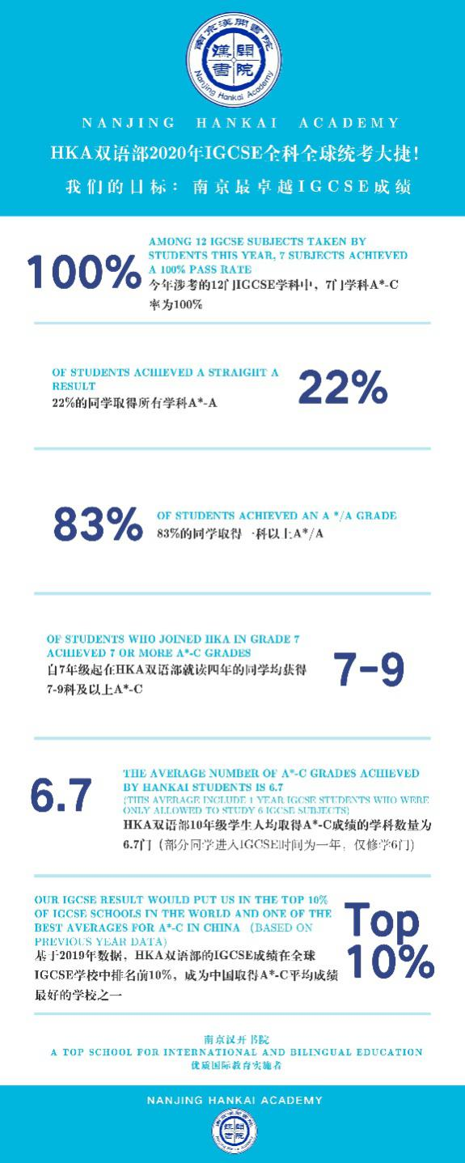

以下图片涉及中文的部分翻译

南京汉开书院2020年IGCSE国际考与2019年世界平均各科达A*率对比

Comparison of the 2020 IGCSE International Examination of Nanjing Hankai Academy and the world average A* rate of each subject in 2019

南京汉开书院2020年IGCSE国际考与2019年世界平均各科达A率对比

Comparison of the 2020 IGCSE International Examination of Nanjing Hankai Academy and the world average A rate of each subject in 2019

南京汉开书院2020年IGCSE国际考与2019年世界平均各科达B率对比

Comparison of the 2020 IGCSE International Examination of Nanjing Hankai Academy and the world average B rate of each subject in 2019

南京汉开书院2020年IGCSE国际考与2019年世界平均各科达C率对比

Comparison of the 2020 IGCSE International Examination of Nanjing Hankai Academy and the world average C rate of each subject in 2019

加数 Add Math

生物 Biology

化学 Chemistry

计算机科学 Computer Science

经济 Economics

语文 Chinese

西语 Spanish

全球视野 Global perspectives

数学 Maths

物理 Physics

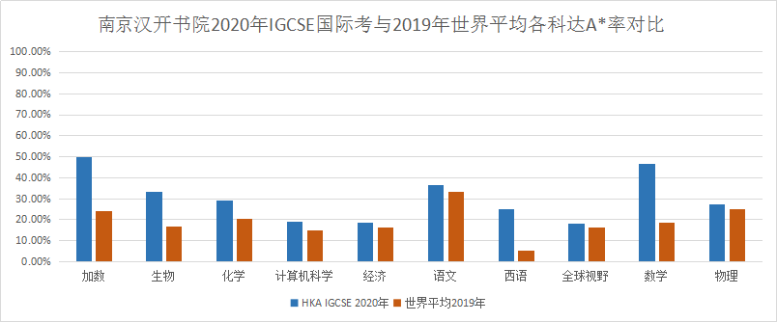

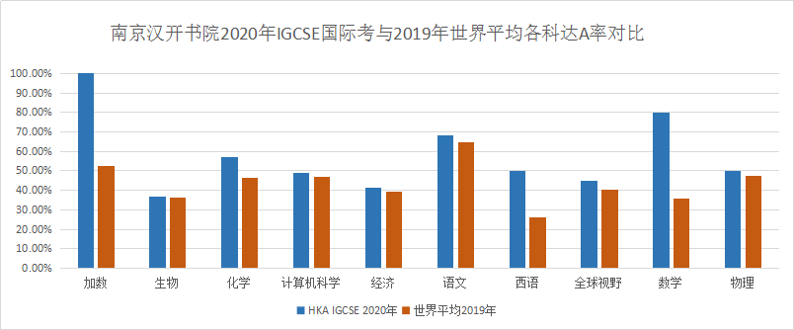

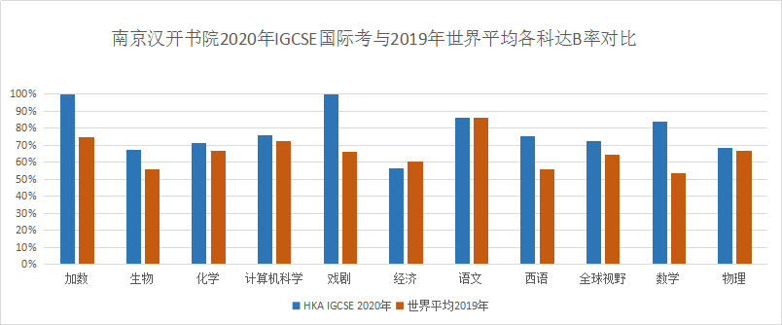

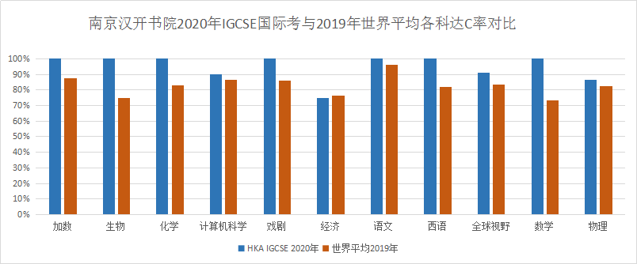

**学子风采**

本次考试九年级数学也取得了极其优异的成绩，参加数学较难extended等级考试的同学，有50%获得最高等级A*，他们是曹沈会、陈梓菡、王子匀、杜茂成、金阳、吴迪、孙大圣、陈坤铭、王淑仪、陈奕粲、郑新、姜子皓、徐玮泽、张乃心、徐天悦、吴锦琳。

十年级的学长、学姐们也为下一届设了更高的目标。让我们来一睹他们的风采吧。

十年级学霸榜

加上9年级的几个学生图片和介绍

“平平无奇”的数学小天才们

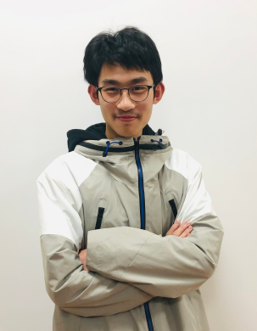

孙大圣 Sherlock



王淑仪 Icey



徐天悦 April



徐玮泽 Chad

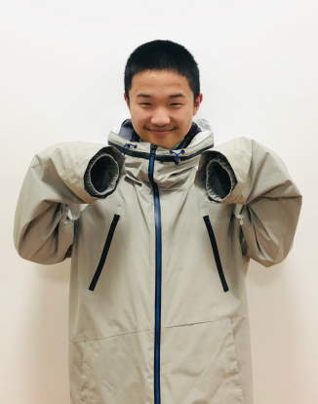

姜子皓 Jerry



薛睿孜 Helen

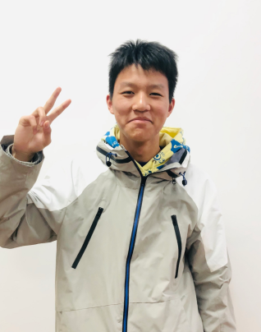

金阳 Jay

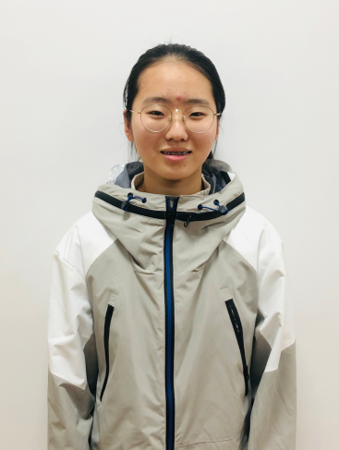

张乃心 Janice

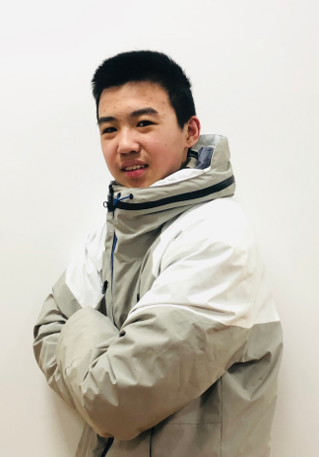

陈奕粲 Andy

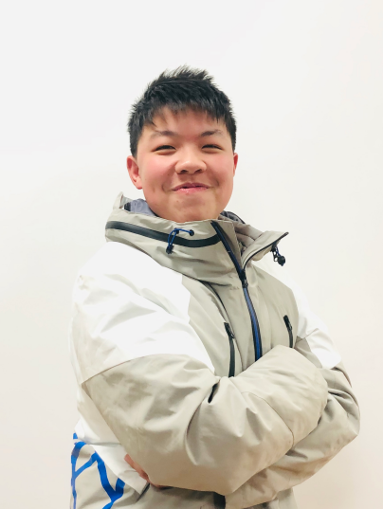

吴迪 Michael



郑新 Jack



杜茂成 Eric

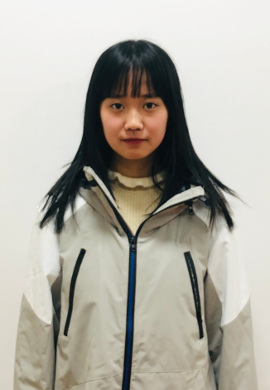

吴锦琳 Katie

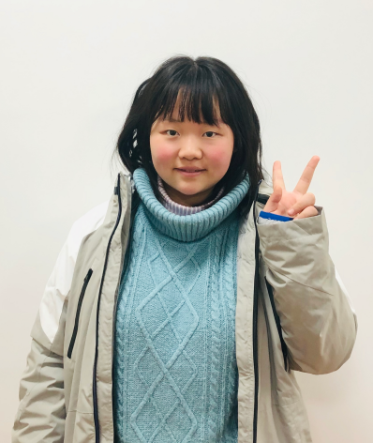

王子匀 Josie

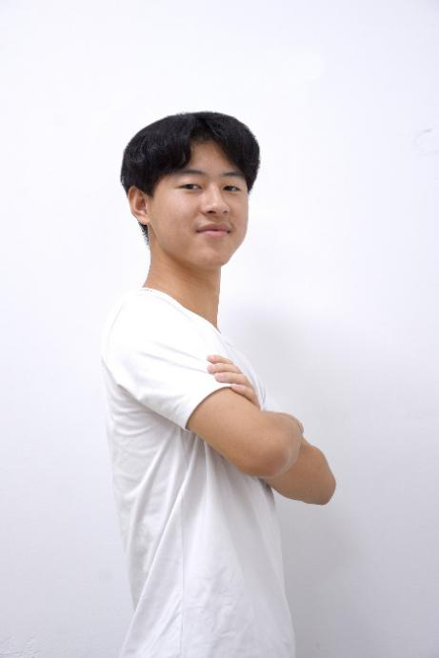

陆伊凡Ivan

IGCSE全科7A* 1A 1B

斩获8个A/A*

自信努力，全面发展，追求卓越。



王欣贝Krystal

IGCSE全科4A* 3A 1B

斩获7个A/A*

多才多艺，秀外慧中。



胡英豪Robert

IGCSE全科2A* 5A

斩获7个A/A*

从东外转来后，用实际行动实现了“成长在汉开”。

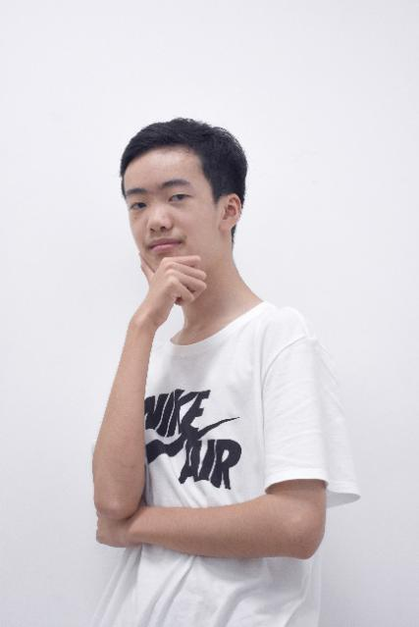

周易Cam

IGCSE全科4A* 2A 1B 1C

斩获6个A/A*

数理化小天才。

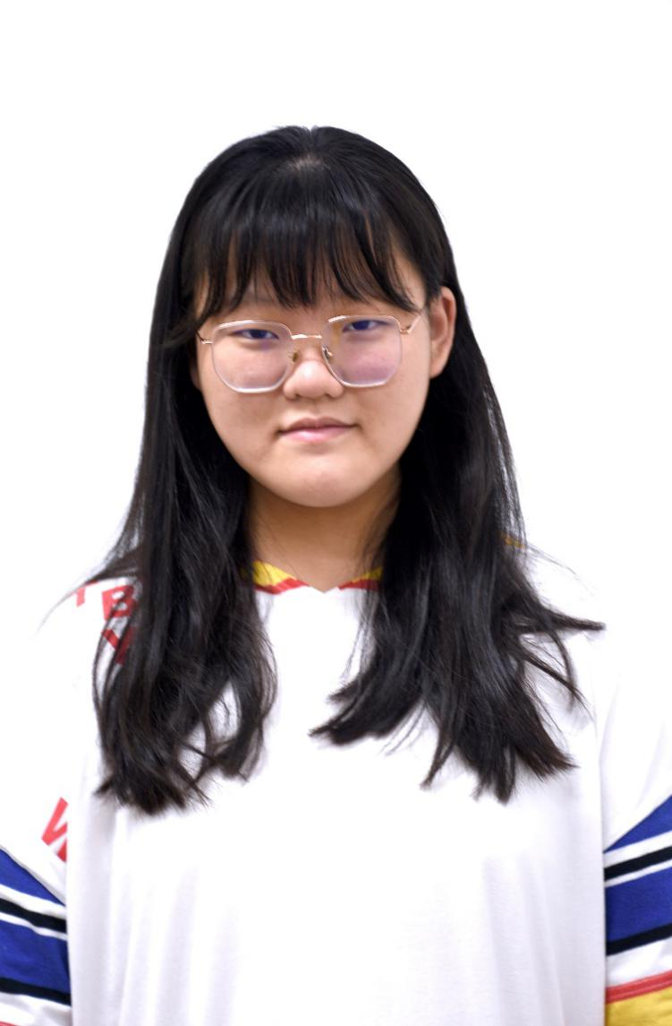

丁家宜Grace

IGCSE全科4A* 2A 1C

斩获6个A/A*

班长的领导力也同样体现在对自己学业的掌控上。

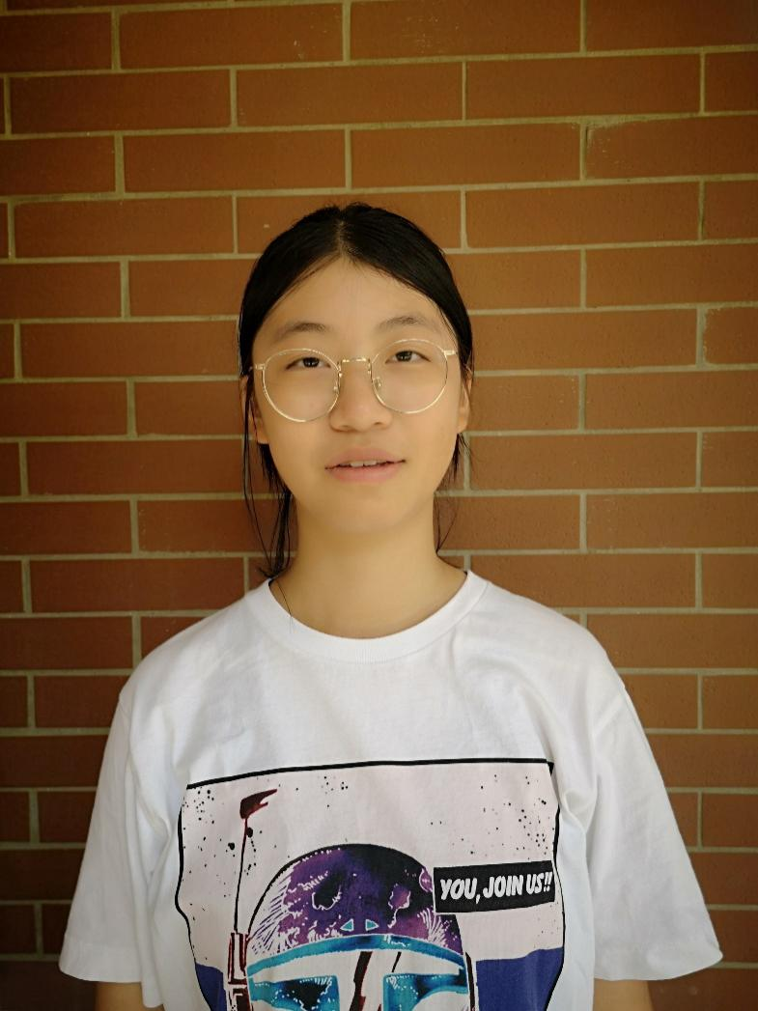

许昊雯Jenny

IGCSE全科4A* 1A

斩获5个A/A*

求知，进取。梦校，我来了！

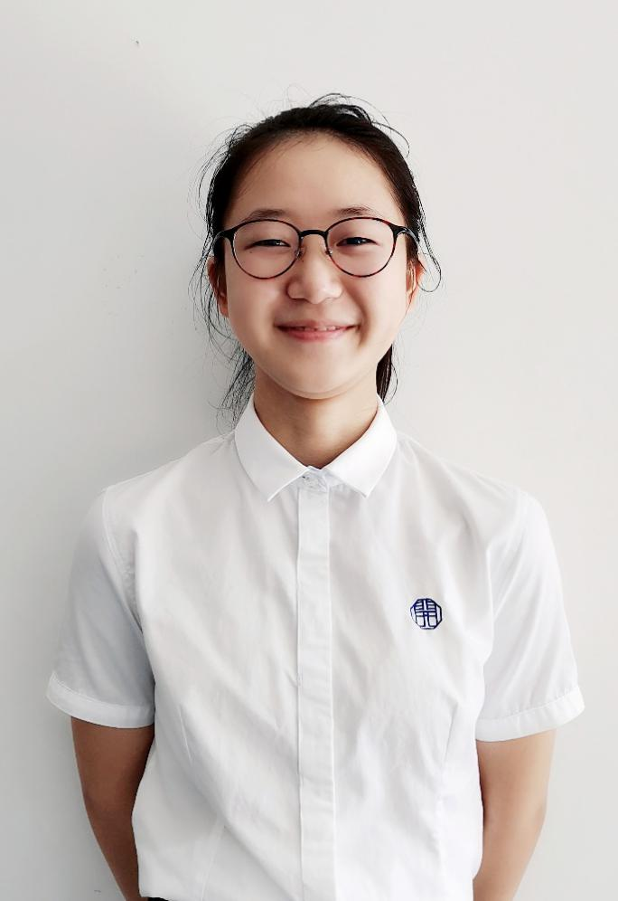

周溢凡Catherine

IGCSE全科2A* 2A 1B

斩获4个A/A*

作为新生，不甘示弱，后来居上！



刁珝恒Sherlock

IGCSE全科3A* 2B 1C

斩获3个A*

扇子哥，把自己喜欢的事做到极致。



陈竑学Eric

IGCSE全科1A* 2A 5B 1C

斩获3个A/A*

跳级而来的内敛小绅士，不断挑战自我，选修全班最多九门IG学科！

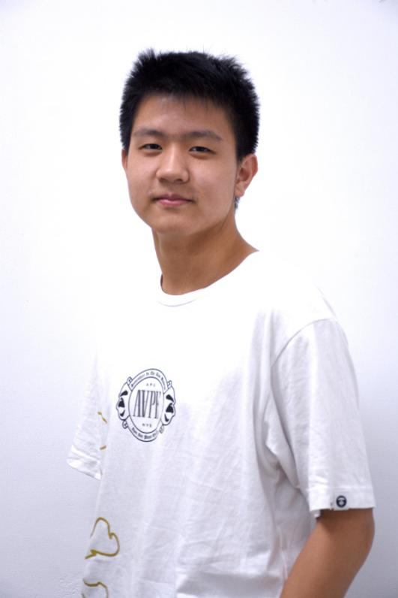

庄智皓Jerry

IGCSE全科1A* 2A 1B

斩获3个A/A*

从台湾初来乍到，有条理地展开新的学业生活

**Chris主任寄语**

It’s been an interesting year and the world has thrown a lot at us, Covid 19, Donald Trump, floods and finally Cambridge cancelling the regular examination series. However through all the problems we have endured together this year we can see the students’ efforts bearing fruit.  Our results proved strong, on par with any top school offering IGCSEs.

Despite all the difficulties over 20% students were awarded straight As and A* grades, congratulations to Ivan on gaining 9 separate subjects, a high bar to set for the students next year. I am pleased to see all the students who came to Hankai Academy in year 7 were able to gain 100 % passes. The programme we laid down has given the students the best possible start into the final push towards university qualifications.

For those few students not achieving the grades they would have liked we have still secured you a pathway to university, your journey can continue uninterrupted, please redouble your effort you still have your place at university to claim.

For the majority of our IGCSE subjects we were awarded 100 % passes with all students taking those subjects able to attain passing grades. Through the chaos of the year the class have emerged victorious, please hold your heads high, be proud of the results you have achieved. Thank you to all Hankai teachers and staff in supporting the student’s accomplishment, I look forward to see the new year 10’s effort to surpass the high standard set by this years students.