IFD Introduction

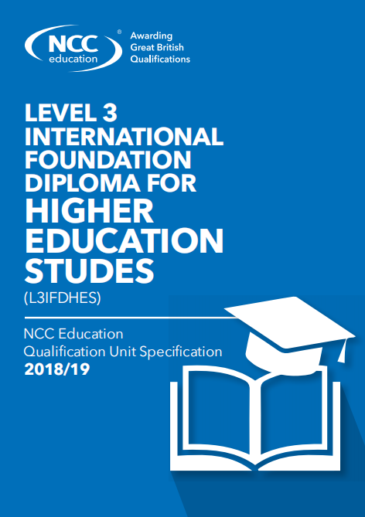
International Foundation Diploma (IFD) is a college preparatory program designed specifically for international students, with a significant amount of English language training. The syllabus was developed and widely recognized by NCC Education. Through this program, students can directly connect with undergraduate programs in major Western countries such as the United Kingdom, the United States, Australia and Canada. In September 2020, the IFD programme of Nanjing Hankai Academy was officially launched, aiming to help students with minor subjects find a path suitable for them and meet the requirements for admission to foreign universities.
- Qualification
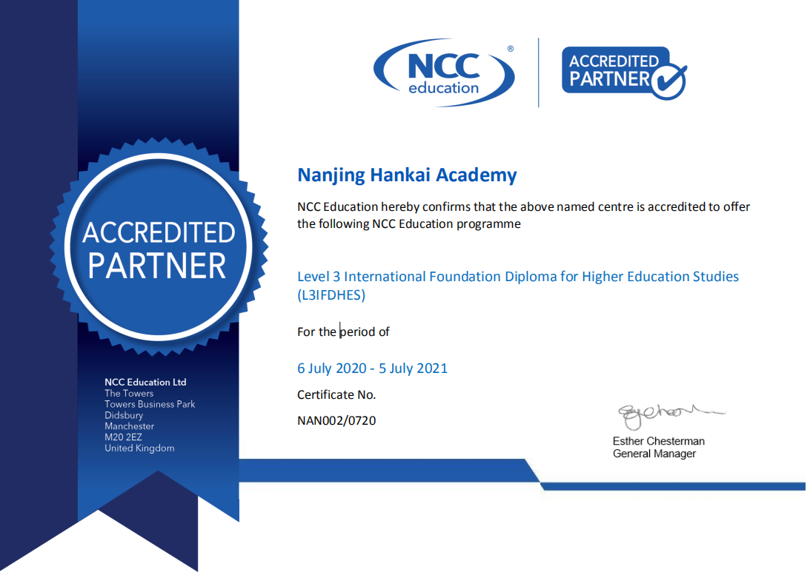
- Programme features
- International
IFD course, designed for non-native English speakers, is a college preparatory course tailored to its curriculum organized by NCC Education. The western countries are widely endorsed by learning this course, since students can directly docking in Britain, the United States, the main western countries such as Australia and Canada undergraduate curriculum.
- Foundation
The IFD program particularly offers a variety of English language courses, including cultural studies, academic writing, and business studies, which prepare universities well for the language.
- Diploma
All IFD graduates will receive the IFD International Baccalaureate officially awarded by the NCC, and will be able to receive a formal offer in exchange for admission (from partner institutions + applications from other institutions).
- Curriculum and assessment method
The IFD program has a comprehensive curriculum to help students improve their academic ability, cultural adaptability and research ability in all aspects to achieve success in further study. IFD courses are divided into compulsory modules and electives, and each student must complete six compulsory modules and two electives. Based on the individual needs and characteristics of HKA students, the following is a two-year curriculum plan:
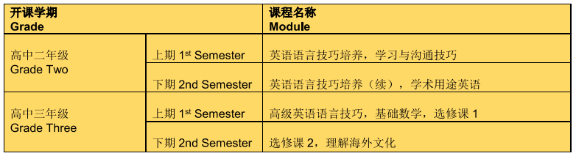
The class hours and credit distribution of the International Foundation Diploma Programme courses are as follows:
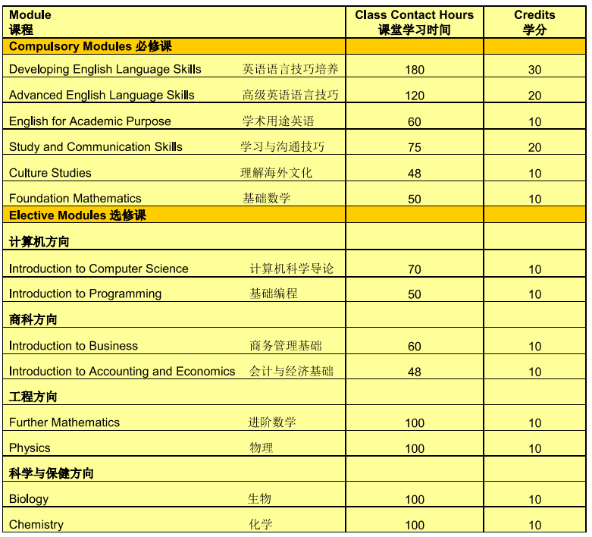
The unit assessment method is very flexible, including local examination, global assessment and global examination. An examination is a time-constrained assessment that will take place on a specified date and usually in an NCC Education Centre. An assignment requires candidates to produce a written response to a set of one or more tasks, meeting a deadline imposed by the Centre. Local Examinations and Global Assignments are marked by the centre.
The overall unit mark is computed from the weighted mean of its components. Students must score at least 40% of each course to earn a diploma, and students who score at least 70 % are rated as outstanding graduates. IFD electives have two directions: computer and business. Students begin their exposure to college computer science or business majors in high school.
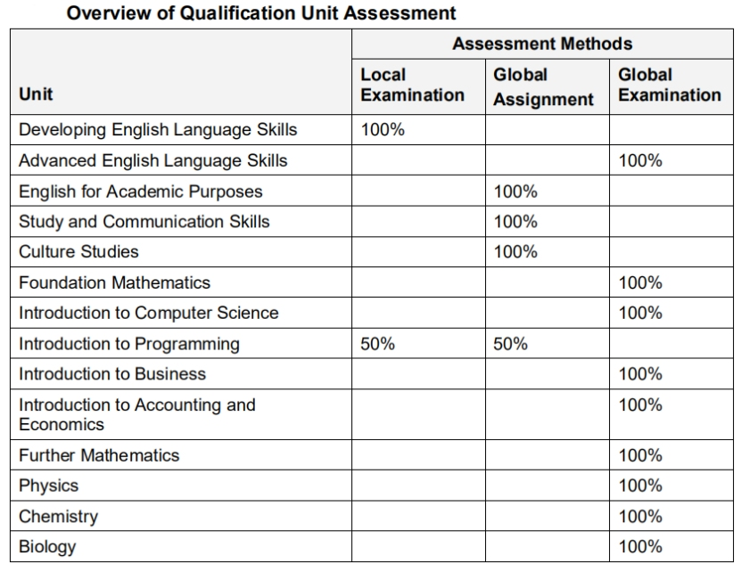

- Where IFD graduates go
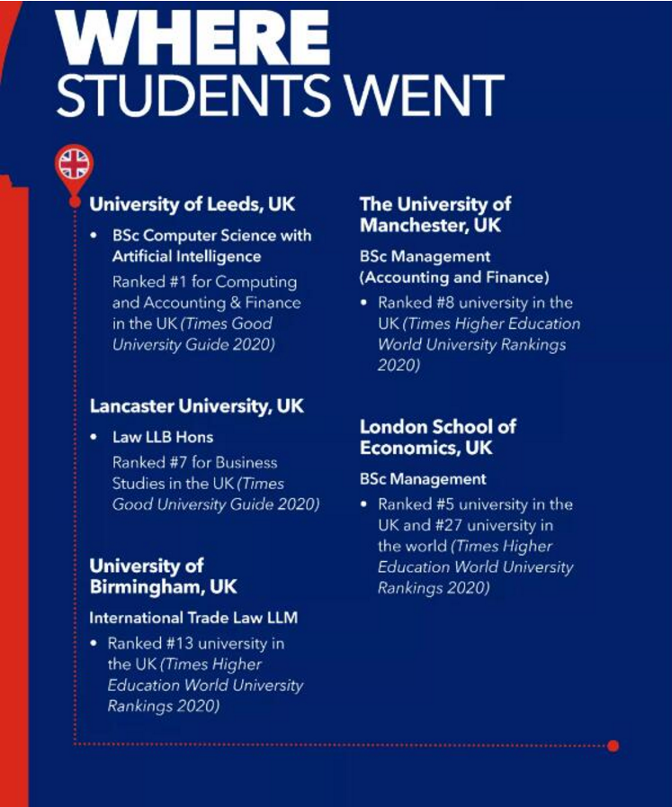
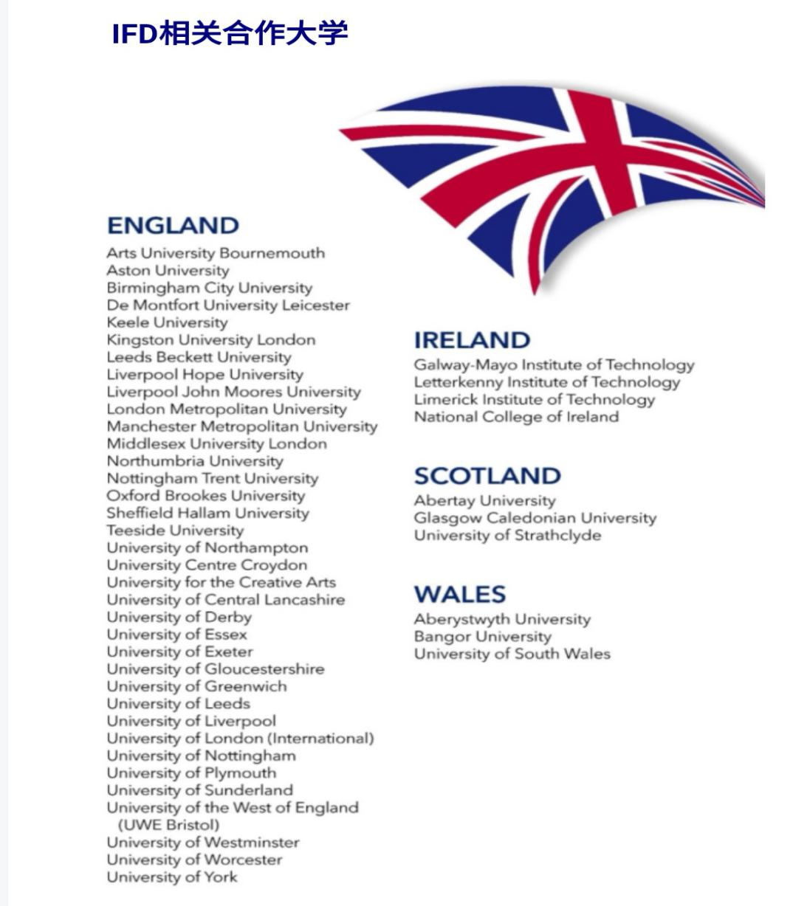
- Support from teachers
Since its inception in 2019, the IFD programme of Nanjing Hankai Academy has offered a total of three compulsory subjects for now, including Developing English Language Skills (DELS), English for Academic Purpose (EAP) and Culture Studies (CS).The other three compulsory subjects covering Advanced English Language Skills (AELS), Study and Communication Skills (SCS) and Foundation Mathematics (FM) will also be introduced next semester. Furthermore, in order to enrich their course experience, Chinese, IELTS, PE and Maths are also offered simultaneously.
The following is the basic situation about offered courses in HKA:
- Developing English Language Skills by Olive Wang and Sierra Sun
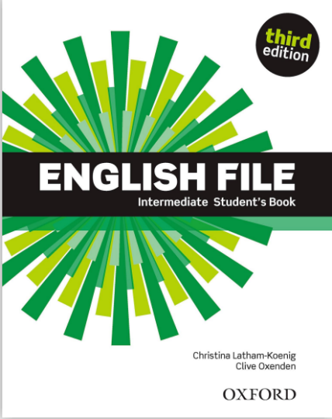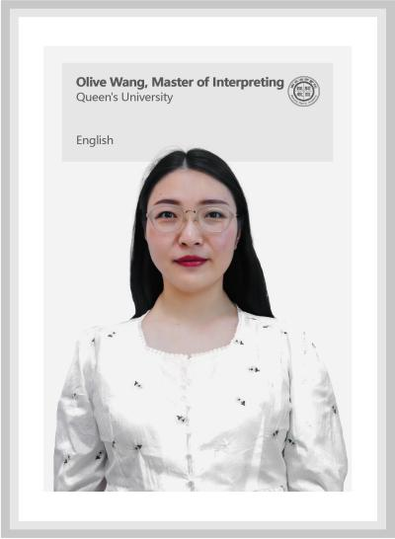
What teachers said:
Developing English Language Skills (DELS) is a language course that help students of all language level build up their English language skills. We have been dealing with coursebook which incorporates vocabulary bank, grammar bank, listening, speaking, reading and writing, and workbook which includes all helpful exercises related to what students have learned in each unit. Content in this course was scientifically designed with a practical English section which gives students practical instructions to use English to deal with different situation in their daily life. And a Revise and Check section every 2 unit help students review and test.
- English for Academic Purpose by Trey Brooks
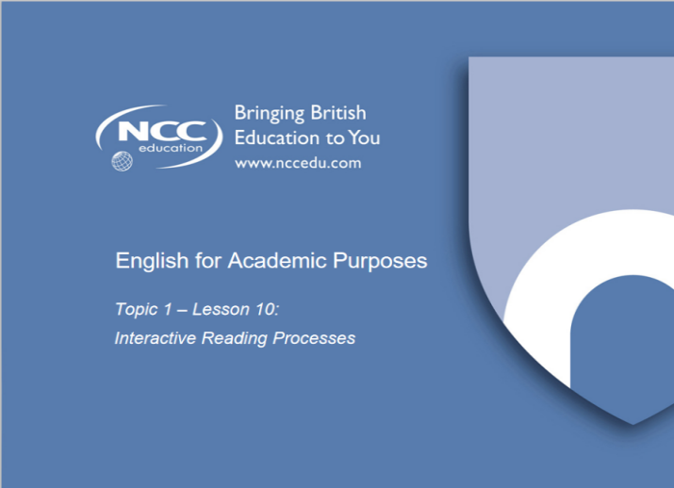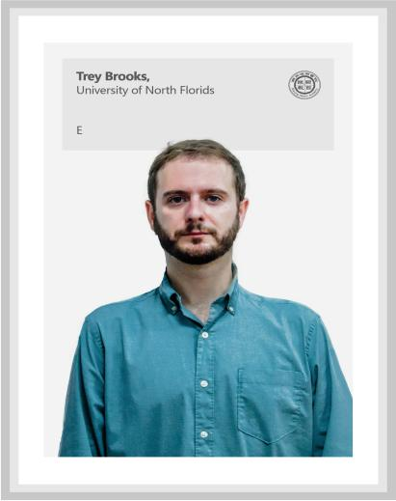
What teacher said:
This semester in IFD we have learned the different types of punctuation, how to write different kinds of sentences, how to write paragraphs, and how to write essays. With sentences we learned the different parts of a sentence, how to write simple, compound, and complex sentences. We also learned how to conjoin them with coordinating conjunctions and subordinate conjunctions. With paragraphs we learned about topic sentences, supporting sentences, and conclusion/transition sentences. We also learned how to link the paragraphs to make them cohesive and fluid. For essays we learned about the different parts of an essay, and how to write a 5 paragraph essay. We also learned how to research, outline, and properly cite an essay. Now, at the end of the semester, we are putting all of these tools to practice and writing 5 paragraph persuasive essays.
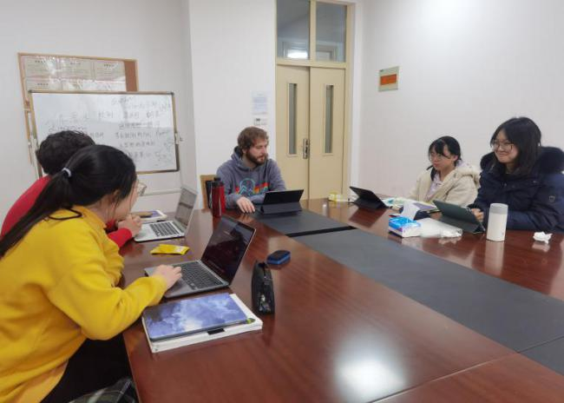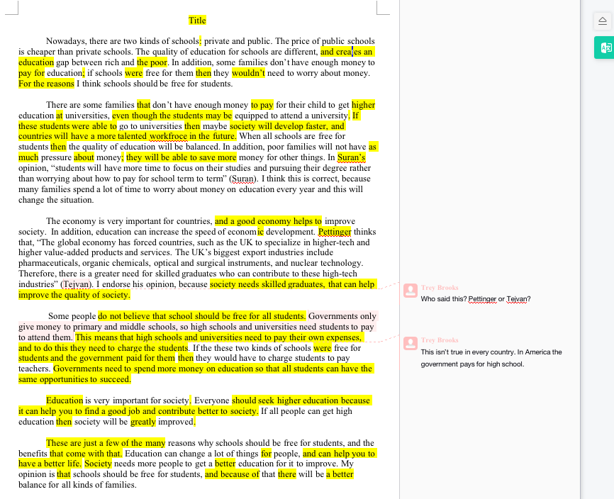
- Culture Studies by Rony Alexander Tovar
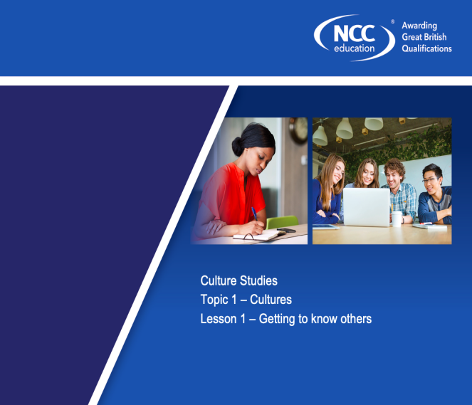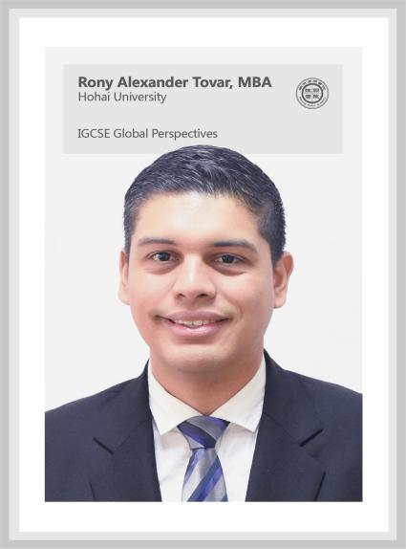
What teachers said:
During this semester students were introduced to many topics in order to develop critical thinking. Some subjects taught were: culture, subculture, government, values, education system, work and digital culture. Though some topics were very complex they were taught with many class activities, visual aid and worksheets in order to facilitate the information. Many of the topics had a hard level of English but with these methods of teaching it helped with the students understanding.
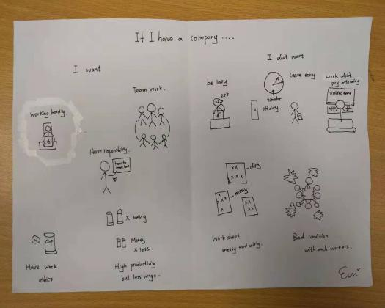
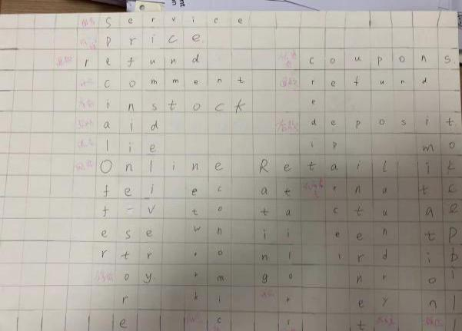

Destination

