UAV engine unit FG-100TS
Our UAV engine module comes as a fully integrated solution. All systems come as one unit for easy installation and maintenance. Our module is fully compatible with Pixhawk family autopilots. The engine unit has a remote start, so you can start it with just one click or push of a button, an electric generator to power up all electric equipment onboard your UAV. We equipped our engine units with a fuel level sensor, engine temperature sensors, air temperature sensors, RPM sensors to provide you with the full and required information. In our system installed additional option that can automatically restart the engine during the flight.
Our team can customize and integrate the UAV engine module according to your technical requirements.

The set of UAV engine unit consists of:

- Internal Combustion Engine | - Starter-Generator
- Electronic ignition | - Electronic Speed Controller
- Throttle servo actuator | - Set of sensors
- ICE Cooling system servo actuators | - Fuel tank
- Servo-drivers | - Spare parts
- Propeller | - Transport case
- Motor Mount
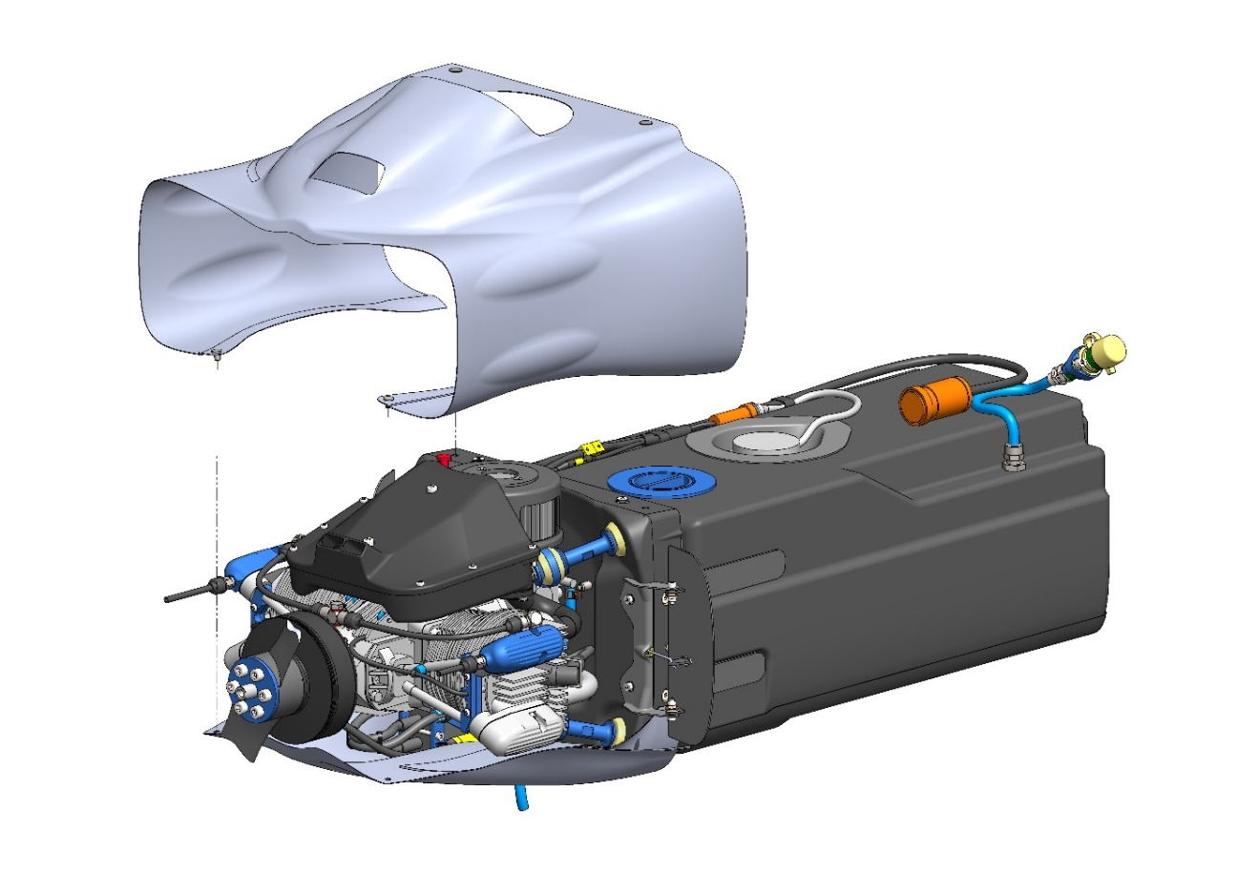
Technical data:

System Specifications
Range | rpm | 1500-6300
Engine operation temperature | c° | 90-140
Propeller | in | 26
 | pitch | 12
Fuel tank capacity | l | 11
Empty weight | kg | 7,8
Maximum working altitude | m | 5500
Power | hp | 7
Onboard power supply (Nominal voltage) | vdc | 24
Onboard battery |  | 6S Li-Po
Battery capacity | mAh | 5400
Output electrical power | w | 300
Main features of system & starter/generator:
Remote engine start |  | +
Brushless motor starter/alternator |  | +
Overcurrent protection |  | +

Dimensions:

