Refresh Energy Drink Inc.
  - Description for a store agreement between
Date: _____________ | Sales Person | Store
 | (YOUR NAME)  (YOUR ADDRESS) | Name: __________________  Address: _________________  ________________________

For every order made the store agrees to fill in the sales person’s email in order for comission to be tracked and paid out to the sales person.

Sales Person’s Email:
YOUR@EMAIL.COM
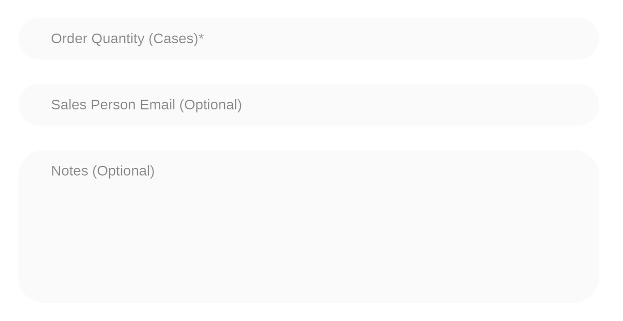

Contract Duration
The period of the contract starts with the signature date. The termination of the contract is unlimited.
By signing this agreement both parties agree to the terms and conditions mentioned in this contract.
Store | Sales Person
Name: ___________________ | (YOUR NAME)
________________________________ ________________________________

