Refresh Energy Drink Inc.  Zurich, Switzerland | 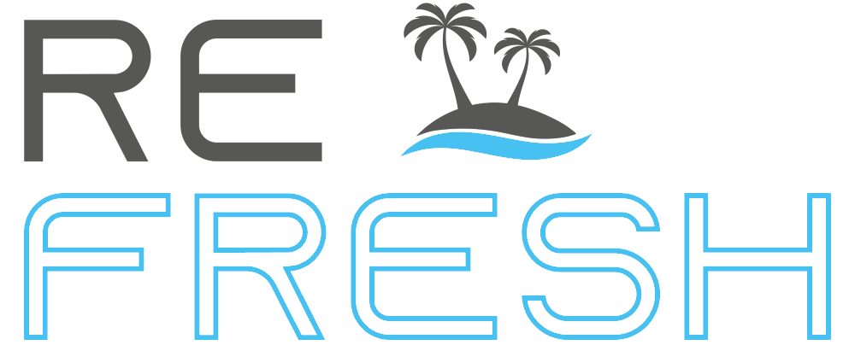
  - Description for an agreement as sales person between
Date (FILL IN DATE) | Contractor | Employee
Email: (FILL IN EMAIL) | Refresh Energy Drink Inc.  Zurich, Switzerland | (YOUR NAME)  (FULL ADDRESS)

The contract is a detailed summary of the description on the website (www.refresh-energy.com). Changes of the website are possible.

Contract Duration
The period of the contract starts with the signature date. The termination of the contract is unlimited.

Payment Conditions
The contractor has 30 days from the date of order to make any required payment to the employee.

Trade Mark
The employee is allowed to use all material like logos, pictures and texts of the Refresh Energy Drink brand as long as it supports the sale of the company’s products.

Support
The employee can reach out to our support team at work@refresh-energy.com at any time if there are questions or issues.

Bank Account Information
Please fill out your bank account information below so we can make your future sallary transfers.

IBAN:
BIC/SWIFT:
Account Name:
Address:
Bank Name:
Bank Address:

Ruleset
For every order created (minimum order quantity is 40 cases) the employee will get paid $100 in cash (bank transfer) as long the customer chose the sales person’s email on the order form. If the order was made without choosing the sales person’s email we are not able to track the sales and not able to pay any sallary for that order.

*This agreement can be signed from any employee of the Refresh Energy Drink Inc.
By signing this agreement both parties agree to the terms and conditions mentioned in this contract.

Employee | Contractor
(YOUR NAME) | Refresh Energy Drink Employee*

________________________________ ________________________________

