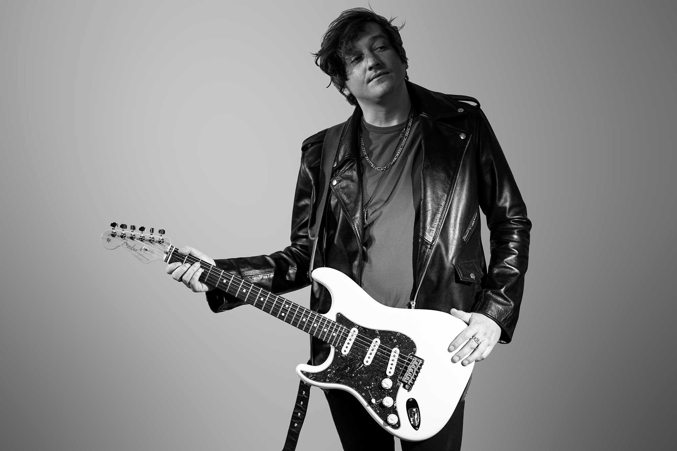

Bio

If Neil Young went pop and sang on a Killers record with an 80s Springsteen vibe, you get a feel for the distinctive sound of DD Allen.

His rousing live performances are responsible for sold-out shows, a string of UK festival appearances, and a 2019 European support for LA-based Vintage Trouble.

The modern-day pop-rocker is no stranger to layering musical styles. And it’s no surprise considering his musical journey.

With his teens fed by a diet of 80s and 90s guitar rock, Allen took a more introspective direction when he began writing songs.

Out went the big riffs and in came Dylanesque style storytelling wrapped in an energetic solo-acoustic delivery.

His style immediately grabbed the attention of James Blunt who claimed, “There’s something exciting about the music of DD Allen. Sort of a cross between Neil Young and Jake Bugg with a great deal of honesty in lyrics.”

But the young songwriter didn’t stay solo for long. Irritated by a folk circuit that found his sound too edgy, Allen took a path inspired by his peers and went electric.

His debut single Just Like The Old Days (Oct 2016) arrived with all the energetic intent of a Killer’s anthem and found immediate support from Indie Shuffle.

The sophomore release Rebecca’s Curse (Jun 2017) premiered on Atwood Magazine, striving to carve out its own space and rise above the mainstream by emerging as a subtle and poignant statement to despair.

Allen’s 3rd single, Never Felt So Far From You (Feb 2018), saw a brief excursion into Americana and placement on Spotify’s official ‘Fresh Finds’ playlist.

Continuing to find favour with an audience intrigued by Allen’s persistent reinvention, 2019 saw a return to the singer’s early rock guitar influences with a 2-track EP release called Bad Love.

The same-titled lead single served as a homage to The Rolling Stones early ‘Exile on Main Street’ period. While Just a Little More saw a nod to the influences of heartland rock’s finest with a rousing sing-along chorus “On the streets tonight, the songs all call your name.”

But in all of this, lay a hint that DD Allen is an artist perpetually evolving his sound.

After a brief excursion into pop-rock with his early 2020 release Seattle Lights, Allen reveals prominent 80s inspiration with I See You In the Dark.

And between the two 2020 releases comes a subtle twist of unintended irony:

Allen wrote Seattle Lights in the festive season outdoor bar-buzz and bright lights of his hometown, Bournemouth, in the UK.

I See You in the Dark is written in a different time. When the lights aren’t shining so bright during the pandemic.

“Although I wrote I See You in the Dark about a broken romance, managing isolation, and the ‘yearning for what was and might be again’. . . the narrative seems to have a wider context in today’s climate,” he claims. “People have lost a lot of the buzz that makes life so great. But we know it’ll all come back.”

I See You in the Dark is released worldwide on 13 November 2020.

Spotify: https://ffm.to/ddallenspotify
Apple Music: https://ffm.to/ddallenapplemusic
Official Site: https://ddallen.com
Facebook: https://www.facebook.com/ddallenofficial
Instagram: https://www.instagram.com/ddallenofficial
Twitter: https://twitter.com/ddallenofficial
Soundcloud: https://soundcloud.com/ddallenofficial
YouTube: https://www.youtube.com/ddallenmusic

Press Kit with downloadable images and logos: https://ddallen.com/press-kit

Quotes

“DD Allen has done it again, a fantastic artist”
— Alex Graham, BBC Radio Solent

“The gorgeous voice of DD Allen”
— Fern Balch, BBC Radio Solent

"DD Allen is making the kind of music deserving of any main stage at any of the top festivals. He's a huge talent. Awesome voice and a great songwriter. I'm anticipating big things."
— Matt Spracklen (TV Judge, BBC1 Altogether Now TV, Mainly Music Pod, Hard Rock Cafe Piccadilly Circus Ambassador)

“DD Allen has a brilliant voice. It harks back to the period of great charismatic singers such as Dylan, Van Morrison, Neil Young and Leon Russell — those singers that you only needed to hear a few lines to know who they are.”
- Stuart Epps (Music Producer — Elton John, Robbie Williams)

“A very, very cool band.”
- Rob da Bank (Bestival, Camp Bestival founder)

“There’s something exciting about the music of DD Allen — sort of a cross between Jake Bugg and Neil Young with a great deal of honesty in his lyrics.”
- James Blunt

“DD Allen is a storyteller in the mould of Bob Dylan and Neil Young. I listen to hundreds of new albums a year but it has been a very long time since I have heard more beautifully written songs. DD Allen really is that good.”
- Louder Than War

“Oozing confidence and direction, DD Allen is the real deal with an awesome stage presence.”
- Bournemouth Daily Echo

Festivals Played
Boardmasters, Larmer Tree Festival, Purbeck Valley Folk Festival, Camp Bestival, Chagstock, Teddy Rocks, Smoked & Uncut, Tonefest, Arts By The Sea, Electric Picnic (Ireland), Grooves On The Green, Dorset Midsummer Festival, SUBU Summer Ball.

Highlights
2014: Selected to support James Blunt at the BIC.
2015: Selected to perform for UN General Secretary Ban-ki Moon.
2016: Awarded ‘Best International Music Video’ at the Cardiff Film Festival.
2017: Regional winner, Pogues Irish Whiskey Shot at Discovery.
2017: National finalist, Pogues Irish Whiskey Shot At Discovery. (O2 Islington.)
2017: National finalist, Bestival Invaders of The Future.
2017: National finalist, Best of British Unsigned Male.
2017: First headline show. (The Old Fire Station, Bournemouth.)
2018: Featured on Spotify’s official ‘Fresh Finds’ playlist.
2018: Curated and trended on ReverbNation’s new ‘Discover’ app.
2018: Featured on tastemaker Matt Spracklen's ‘Mainly Music Podcast’.
2019: Supported Vintage Trouble in the Netherlands.
2019: Headlined Grooves on the Green festival.
2019: Sold-out show at the Lighthouse, Poole. (Live and Unheard.)
2020: Live and Unheard ‘Bestsellers’ headliner at The Brook, Southampton.

Influences
Bob Dylan, Neil Young, Ryan Adams, Bruce Springsteen, The Killers

FFO
The Killers, Bruce Springsteen, Night Traveler

Contact
Management: Phil Allen | +44 (0) 7702 102030 | phil.allen@ddallen.com

