**Title (Capitalize Each Word)**

**First Author1*, Second Author2 and Third Author3**

**(The first name(s) and last name (s) of the author(s)**

1*Corresponding Author’s Email:

1*,2,3Affiliation (Department, Faculty, University) and address(es) of the author(s)

**Abstract**

Please provide an **abstract of 150 to 200 words**. The abstract should not contain any undefined abbreviations or unspecified references.

**Keywords:** Keyword1, Keyword2, Keyword3, Keyword4, Keyword5

**Introduction**

Manuscripts should be submitted in Word.

* Use a normal, plain font (e.g., **12-point Calibri**) for text.
* Use italics for emphasis.
* Use the automatic page numbering function to number the pages.
* Do not use field functions.
* Use tab stops or other commands for indents, not the space bar.
* Use the table function, not spreadsheets, to make tables.
* Use the equation editor or MathType for equations.
* Save your file in doc format (Word 2003 or 2010) or doc format (older Word versions).

**Literature Review**

**Headings**

Please do not use the decimal system of headings.

**Research Methodology**

Table 1

*Demographic Profile of Respondents*

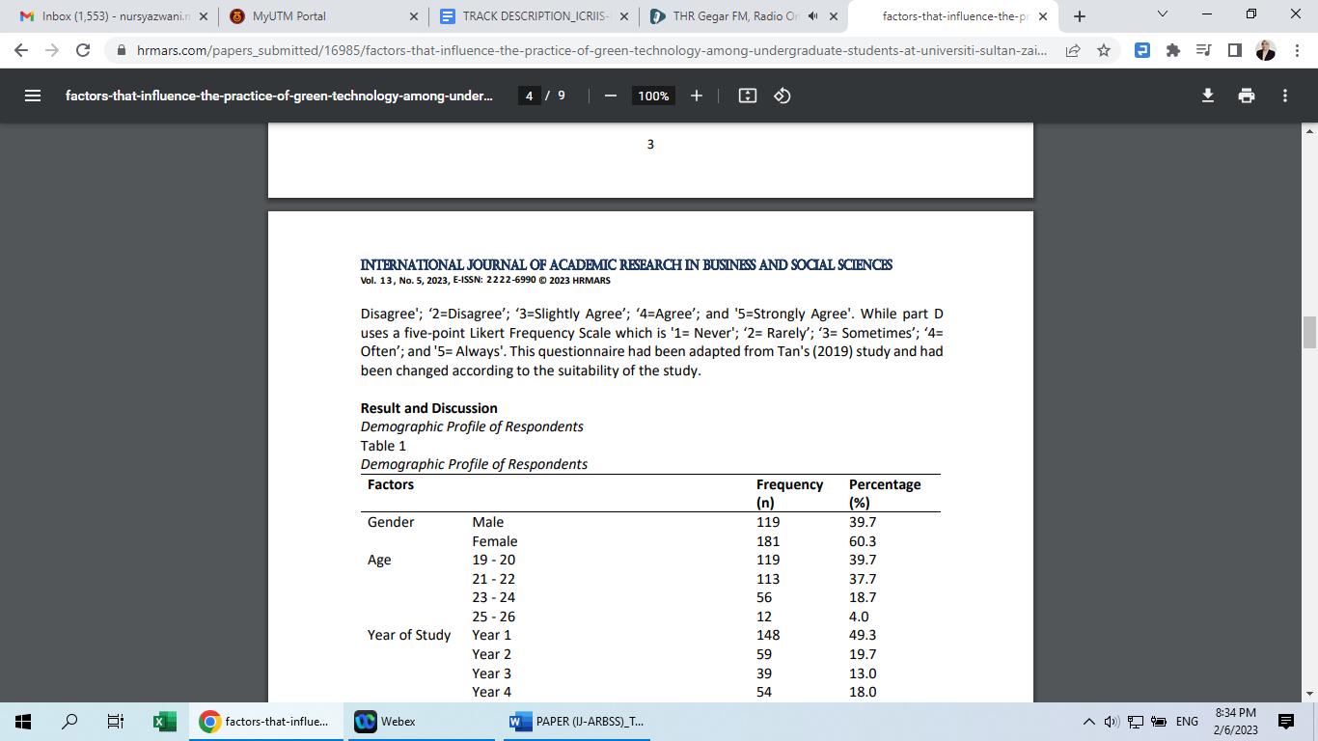

**A Proposed Conceptual Model/Framework**

*Figure 1.*The Proposed Conceptual Model/Framework

**Results and Discussions**

**Conclusions**

**Acknowledgments**

Acknowledgments of people, grants, funds, etc. should be placed in a separate section (end of the document) before the reference list. The names of funding organizations should be written in full.

**References**

The list of references should only include works that are cited in the text and that have been published or accepted for publication. Personal communications and unpublished works should only be mentioned in the text. Do not use footnotes or endnotes as a substitute for a reference list. Reference list entries should be alphabetized by the last names of the first author of each work. Please use the APA (American Psychological Association) referencing style. For detailed information, please see the *Publication Manual of the American Psychological Association*, 6th edition, <http://www.apastyle.org/> and [http://blog.apastyle.org/.](http://blog.apastyle.org/)

* *Journal article*

Harris, G., Karper, T., Stacks, H., Hoffman, D., DeNiro, R., & Cruz, P. (2001). Management accounting. *Journal of Accounting*, *42*(1), 234–245.

* Book

Calfee, R. C., & Valencia, R. R. (1991). *APA guide to preparing manuscripts for journal publication*. Washington, DC: American Psychological Association.

* Book chapter

Barbu, C. M., & Egan, T. (1992). *Transition – a matter of time*. In Economic (Ed.), *Theoretical and Applied Economics* (pp. 107–123). Bucharest.

Journal names and book titles should be italicized.