Welcome to the 2026 PGYSA Development Team Program!

The primary focus of the Development Team Program is to provide a fun, safe, and positive soccer experience for every player. The objective is to provide competitive opportunities while developing overall soccer skills in a team environment.

Expectations:

- Players, parents, coaching staff and affiliates are expected to treat one another with respect
- Foul or abusive language or behaviour will not be tolerated
- Represent PGYSA Impact in a positive manner at all competitions and team trips
- Keep your coaches/manager updated on any changes (ie: new health concerns, injuries, etc.)
- Arrange your child’s transportation to and from tournaments, games, and practices
- Arrange your own accommodation reservations (your team manager will set up room blocks, but these need to be booked in a timely manner)
- Make every attempt to attend practice regularly
- Communicate attendance and respond to manager/coach correspondences in a timely manner (teams may use an app or email to communicate)

Registration & Costs:

Please reach out if you have any concerns about costs. Information about financial assistance options can be found by emailing the PGYSA office at impact@pgysa.bc.ca.

- Registration for the 2026 Development Team Program/Spring Outdoor 2026 (House League) will be opening soon
- Players are required to register for the Spring Outdoor 2026 (House League) if they wish to participate in the Development Team Program.
- The fees to register for the Development Team Program only cover the training sessions. The cost of travel is not covered within player registration.
- Each travel opportunity will have an expense that will be determined by dividing the team fees by the number of players who are travelling to that event. Tournament fees vary based on age group and location.
  - In previous years these per player costs have ranged from $50-$100 per event and need to be paid in advance. These costs may change for the 2026 season.
○ The PGYSA office will send out a payment link prior to each event.
- Parents/players are responsible for the cost of food, fuel, parking and accommodations.
  - Hotels can range from $150-$375/night depending on the location of the event and typically a one-night or two-night stay is required (many tournaments have a stay and play policy where staying in their pre-approved accommodation is required).
○ Team managers will send out hotel booking information for each event throughout the season.

Schedule:

- The Development Team Program will run between March 30th to September 30th.
- Some age groups may start training over spring break as communicated by team coaches to registered players.
Please note: Practice sessions & games beyond June 30th will vary by team based on coach availability throughout the summer/fall. Specific dates and location will be provided by your team manager.

Tournament Dates:

Below is the PGYSA Development Team Tournament Calendar which shows all our travel plans for the 2026 season
You can also find it on the website at https://pgysa.bc.ca/schedule-1-2

*Schedule is subject to change if coach, tournament or player availability changes
**Other games with regional teams may be added as they become available throughout the season

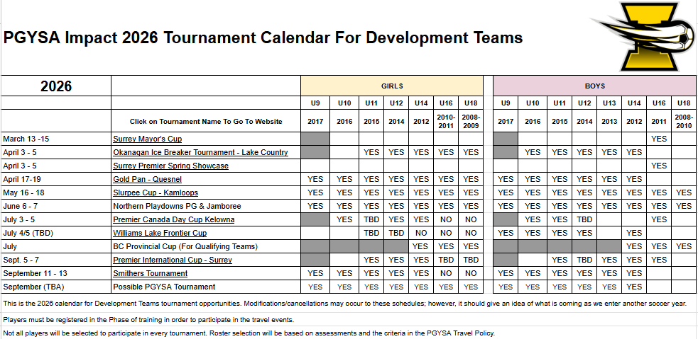

Please complete the survey we have sent along with this letter by Tuesday, February 10th indicating which jamborees and tournaments your child could attend, in order for us to gather tournament availability

- Once coaches/managers and the technical team have all your responses they will be able to make roster plans for each event, register the appropriate number of teams, and provide you with more clarity on the travel opportunities for your child.

Team Structure / Rosters:

- The development team will train together throughout the season.
- It is our aim to provide game opportunities for every player in the development team program.
- While we cannot guarantee travel opportunities for every player registered in the development team program, we will make every attempt while managing various considerations (ie: the size of the travel pool, the appropriate roster size, the level of competition, etc.).
- For local and regional jamborees:
○ Where we have enough players to register multiple teams, we will attempt to create equally balanced teams.
- For larger tournaments (tiered tournaments):
  - Coaches will apply ability-based selection criteria and methodology in team creation for events where tiering is required (if approved in advance by the Technical Director).
○ Where we have enough players to register multiple teams, we will attempt to create multiple tiered teams.

More Information:

• If an age group has more players than can fit on one team but not enough to form two teams, we will unfortunately not be able to bring all available players. Selection will be based on multiple factors, including (but not limited to) assessments, recent game performance, training effort, attendance, attitude, and sportsmanship.
• Players will generally compete within their own age group; however, exceptions may be made based on the same criteria above and with approval from the Technical Director.

This letter was meant to provide families with introductory information about the upcoming 2026 Development Team program, and to allow us to gauge the interest for potential tournaments. You will be given more information over the coming weeks about the program, coach contacts, and next steps as we move closer to the 2026 Outdoor Spring Season.

Coaching Roster:

We are excited about the Development Team Coaching Roster for 2026. This is an exceptionally experienced group of coaches who are prepared to provide the highest level of care and attention to the young players in the programs.

GIRLS BOYS
  Mark Chadwick  Jaime Bauman | 2008-09
  Mark Chadwick  Jaime Bauman | 2010-2011
  Kollin Spencer Martin Power | 2012
  Joanne Bray  Taya Garneau | 2014
  Cara Brawdy  Brett Zurowski | 2015
  Chaley Festerling  Nicole Gibbons | 2016
  Alysa Leclerc  Antonia Tannert | 2017
  Ryan Beer  Karan Bhangu | 2008
  Ryan Beer  Liz Bennett | 2009-2010
  Daniel Mc Aleer  Rob Glavina  Ante Cirko | 2011
  Cam Rhodes  Damian Meehan | 2012
  Matt Mortlock  Andrew Seabrook | 2013
  Colin Schulz  Thomas Gayowski | 2014
  Michael Raper | 2015
  Brian McLaughlin  Anthony Heppner  Rian Hill | 2016
  Sebastian Tannert  Karan Bhangu  Alexa Talbot | 2017
Thank you for your interest and commitment to this years 2026 Development Team Program.
We look forward to making some great memories with all of you throughout the season

